Requirement Analysis
Data Flow Diagram & User Stories
Date | 17 February 2026
Team ID | LTVIP2026TMIDS37778
Project Name | Laptop Request Catalog Item

Data Flow Diagram (DFD):

A Data Flow Diagram (DFD) is a graphical representation of how data moves through a system. It shows the flow of data between processes, external entities, and data stores without describing internal coding logic.

Why Use a DFD?
• Provides a clear understanding of how the ServiceNow system handles request data
• Helps analyze catalog workflows and approval processes
• Identifies inputs, outputs, processing steps, and data storage
• Useful for documentation and system design

Components in a DFD
• External Entities: Users interacting with the Service Catalog (Employee, Admin)
• Processes: Catalog Item Submission, UI Policy Processing, Approval Workflow, Request Generation
• Data Stores: ServiceNow Tables (User Table, Request Table, RITM Table, Catalog Item Table)
• Data Flows: Movement of request data between users, processes, and database tables

Example (Simplified Flow for ServiceNow Laptop Request)
Employee → [Open Service Catalog] → [Select Laptop Request Item] → [Catalog Item Form]
Employee → [Submit Request] → [UI Policy Validation Process] → [ServiceNow System]
ServiceNow System → [Create Request] → [sc_request Table]
ServiceNow System → [Create Requested Item (RITM)] → [sc_req_item Table]
Manager → [Approval Process] → [Approval Table]
Admin → [Fulfill Request] → [Update RITM Status] → [Closed Request]

Data Flow Diagram (DFD):

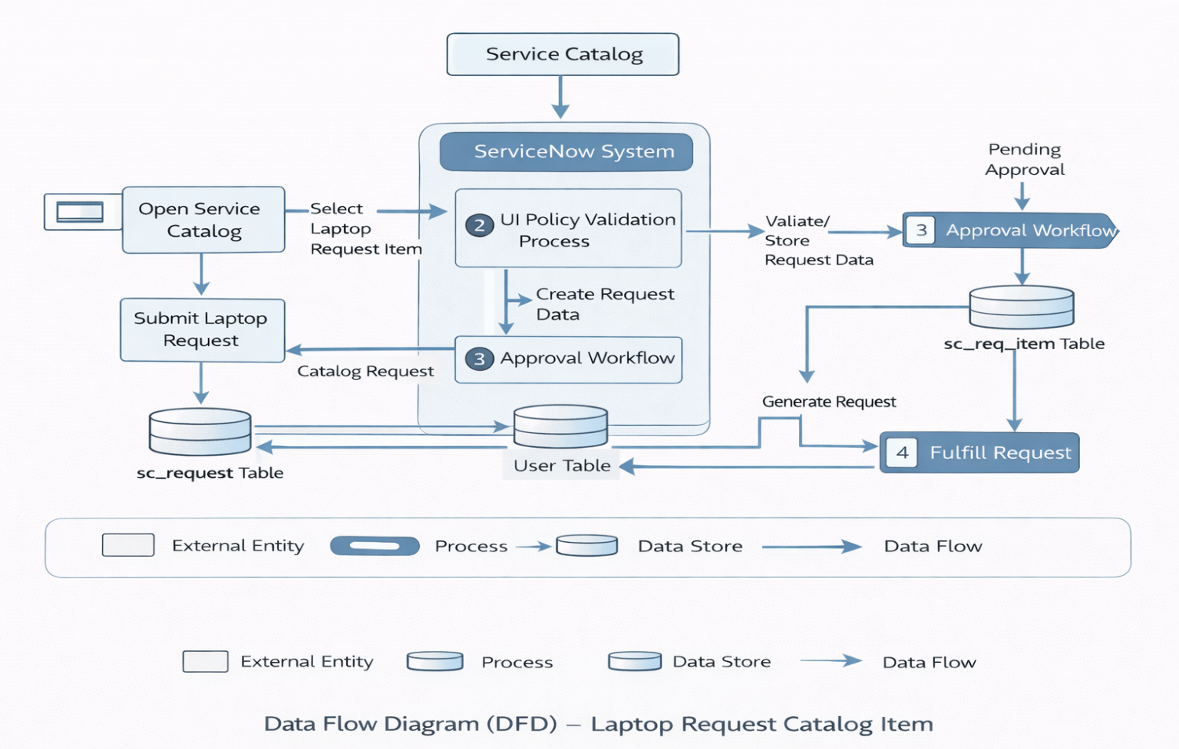
User Stories Table:

User Type | Functional Requirement (Epic) | User Story Number | User Story / Task | Acceptance Criteria | Priority | Release
Employee | Catalog Item Creation | USN-1 | As an employee, I can access the Laptop Request catalog item from the Service Catalog. | I can view the Laptop Request form. | High | Sprint-1
Employee | Form Submission | USN-2 | As an employee, I can submit a laptop request by filling required fields. | Request is successfully submitted and confirmation is shown. | High | Sprint-1
Employee | Dynamic Form Behavior | USN-3 | As an employee, when I select “Additional Accessories”, the Accessories Details field becomes visible and mandatory. | Field visibility and mandatory conditions work correctly. | High | Sprint-1
Employee | Reset Function | USN-4 | As an employee, I can reset the form fields using a Reset button. | All entered values are cleared. | Medium | Sprint-2
Manager | Approval Workflow | USN-5 | As a manager, I can approve or reject the submitted laptop request. | Approval decision updates request status. | High | Sprint-2
Admin | Update Set Export | USN-6 | As an admin, I can export the update set as an XML file. | Update set is downloaded successfully. | High | Sprint-2
Admin | Update Set Import | USN-7 | As an admin, I can import and commit the update set into another instance. | Update set is successfully previewed and committed. | High | Sprint-2
Admin | Request Management | USN-8 | As an admin, I can track and manage all submitted laptop requests. | I can view and update request records. | Medium | Sprint-2

